TITLE OF THE INNOVATION:
Jproteraiodendro Tree (JDT): A Hybrid Distributed Priority-Based Adaptive Tree System for Large-Scale Data Indexing.

PREAMBLE OF THE DESCRIPTION:
This specification describes the innovation and the related architectural framework of the Jproteraiodendro Tree (JDT). It provides an overall guide to the researchers, developers and system architects to understand the design principles, methodologies and operational strategies of the JDT. In this paper, we demonstrate how JDT uses state-of-the-art techniques from algorithmic research, distributed system design, and adaptive structures to address the challenges of today’s large-scale data processing.

DESCRIPTION:
Jproteraiodendro Tree (JDT) is a hybrid data structure combining ordering adaptive branching, and graph routing deliver scalable, lock-free, high-performance indexing for dynamic, distributed systems.

FIELD OF INNOVATION:
The JDT is related to areas including:
* Advanced Data Structures
* Distributed Systems
* Database Indexing
* High-Performance Computing
The JDT is a kind of tree structure that combines different techniques to make it work well with large amounts of data. It uses graph theory and priority-based ordering for easy data location.

REASON FOR THE INNOVATION:
Traditional tree structures has some problems. They can be slow when dealing with amounts of data. They can also be inflexible. Have trouble handling many requests at the same time. The JDT solves these problems by using branching, distributed nodes and priority-driven indexing. The JDT’s goal is to create a system that is efficient and rapid in processing large volumes of data. It should be able to adapt to changing workloads and make sure data is always available.

OBJECTIVE:
Scalable Data Indexing, Priority-Based Data Access, Adaptive Structural Optimization, Distributed Processing Capability, Reduced Access Time for Frequent Nodes, Fault Tolerance and Load Balancing, Efficient Memory Utilization, Real-Time Dynamic Adaptation

WORKING:
Jproteraiodendro Tree (JDT) is a data structure that combines the features of tree hierarchy, graph routing and distributed system. It starts with insertion of data. Priority value is assigned to each node based on the way of accessing it or the importance of the node. The priority determines the position of the node in the structure. In contrast to trees, the JDT can adapt its shape dynamically according to real-time data patterns. Frequently accessed nodes are moved nearer to the root. This decreases access time. The routing mechanism is based on the principles of the graph theory which allows data to have more than one path. This simplifies data extraction from complex data sets. The JDT is designed for distributed environments where nodes are distributed over systems and partitioned into shards. For efficient access, communication between nodes is performed via a central routing component. It processes requests in parallel. The system is lock-free, thus there is no performance bottleneck. Memory is organised in pointer structures to improve cache efficiency, and to reduce latency. The system would be designed to dynamically adapt to changing workloads, load balancing and monitoring performance to ensure continuous and efficient operation.

ALGORITHM WORKING:
The JDT is developing algorithms. The priority assignment algorithm assigns the priority score to the nodes based on their access or importance. The Dynamic Branching Algorithm adapts the tree structure based on the workload patterns over time. The Adaptive Routing Algorithm finds the route to the data using graph-based approaches. It is a Self-Balancing and Redundancy Algorithm. It guarantees the stability and the balance of the structure and redundancy for the fault tolerance. The Load Distribution Algorithm distributes the data and processing load across the nodes or shards.
System operation:
The JDT is not only a container for data, it knows how to deal with data: Smart Insertion &amp; Scoring: Data is given a weight when inserted into the system by a priority algorithm, based on its importance or the frequency it is expected to be accessed.
Adaptive Positioning: The tree is “self-conscious.” If a certain node is accessed often, the system will automatically move it closer to the root (the top level) to greatly improve retrieval times.
Graph-based traversal: JDT uses graph-based routing, not strict hierarchies. This allows the system to have multiple routes to the same data. This makes it so that if some paths in the network get really busy, it can still be efficient.
Distributed Sharding: JDT shards nodes to different servers to handle global scale data and uses a central routing component to keep everything in sync and fault tolerant.

WORKFLOW OF THE PROPOSED SYSTEM:
Fig 1: Architectural Diagram of Jproteraiodendro Tree (JDT)
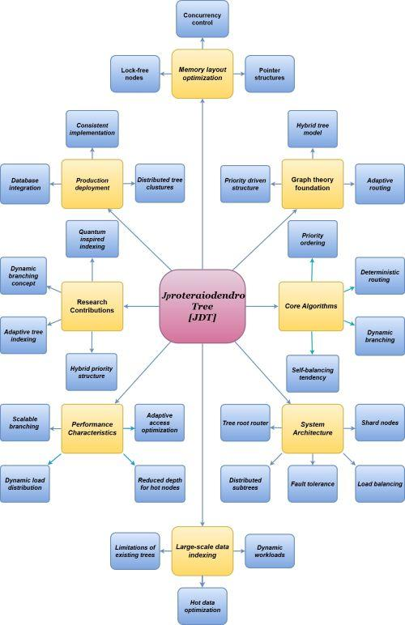

Fig 2: Flow Diagram of Data Insertion and Retrieval Process
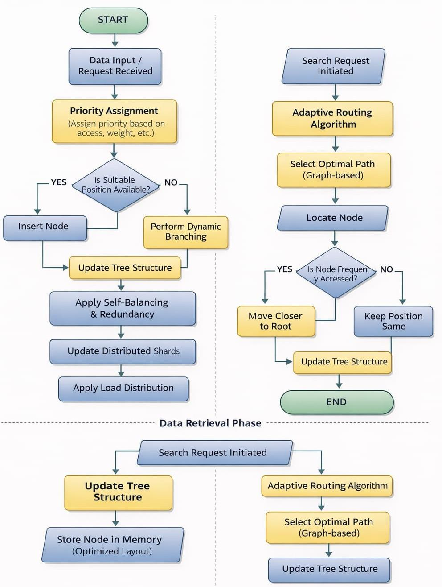

TIME COMPLEXITY ANALYSIS
Because the JDT moves “hot nodes” (frequently accessed data) closer to the root, its performance is highly dynamic.
Operation | Average Case | Best Case (Hot Nodes) | Distributed/Worst Case
Search | O(log n) | O(1) to O(k) | O (log n) + text {network latency}
Insertion | O(log n) | O(log n) | O(log n) + text{sharding overhead}
Deletion | O(log n) | O(log n) | O(log n)

Adaptive Search: For frequently used data, the complexity drops toward O(1) as the Access Optimization Algorithm reduces the depth of these nodes. Concurrency: Using lock-free mechanisms ensures that these time complexities remain stable even under high thread contention.

REAL TIME APPLICATIONS:
Distributed Databases, Big Data Processing Systems, Search Engines, Cloud Computing Platforms, AI & Machine Learning Systems.

SUMMARY:
The Jproteraiodendro Tree (JDT) is a new kind of data structure that solves the problems of traditional indexing systems. It combines priority-based ordering, adaptive branching and graph-based routing to make it fast, scalable and flexible. The JDT is designed to work in distributed environments. Can handle dynamic workloads. It adapts in time and optimizes frequently accessed data making it suitable for modern applications like big data processing, distributed databases and high-performance computing systems. Overall the JDT is an approach to data indexing that combines theoretical innovation with practical system design to deliver a robust and scalable solution. The JDT is a solution, for people who work with large amounts of data and need a system that can handle it quickly and efficiently. The Jproteraiodendro Tree (JDT) is the future of data indexing.

